Medisure Analysis
Time stamp: 12:44 pm
Analyst: Chinonso Eneje

Findings:
IOC TABLE
Originating IP address | 89.144.44.41
Mail | mail.access-accsecurity.com
Reply to | solutionteamrecognizd03@gmail.com
Date | Wed, 16 Aug 2023 00:15:00 +0100
Claim IP | 103.225.77.255
URL | https://sign.in/
Tracking pixel source | thebandalisty.com

URL and Attachment Analysis
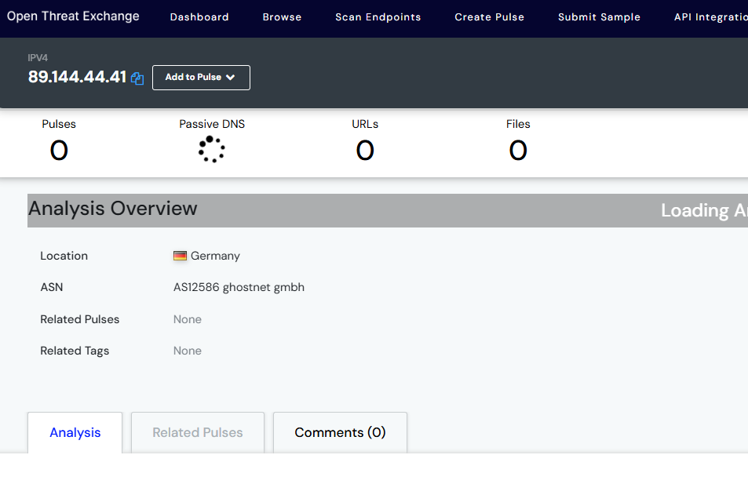
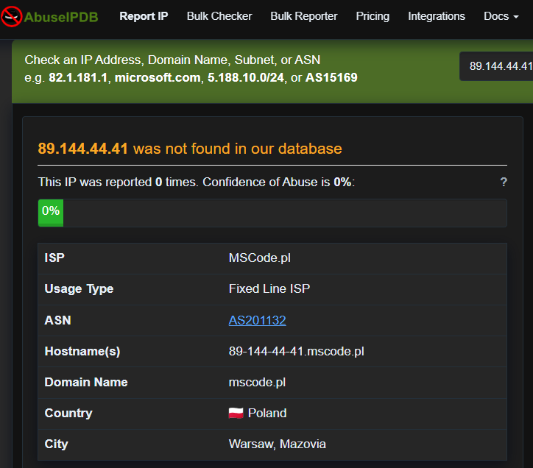Figure1 : image showing status of IP address 89.144.44.41
Even though the IP address was not reported as malicious at Virus total,AbuseipDB, and AlienVault at the time of this investigation, there is a discrepancy in location across this threat detection platforms. AbuseipDB reported that the IP originated from Poland, AlienVault reported that IP originated from Germany while the email claimed that email came from Russia.

Claim
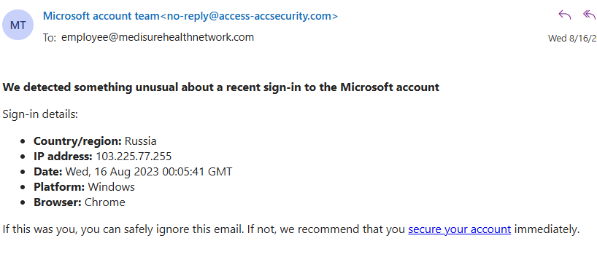Figure2.0 : Image showingFigure5.1 : Image showing body of the suspicious email received.
Another IP address (103.225.77.255) was reported in the mail, the IP was claimed to have originated from Russia

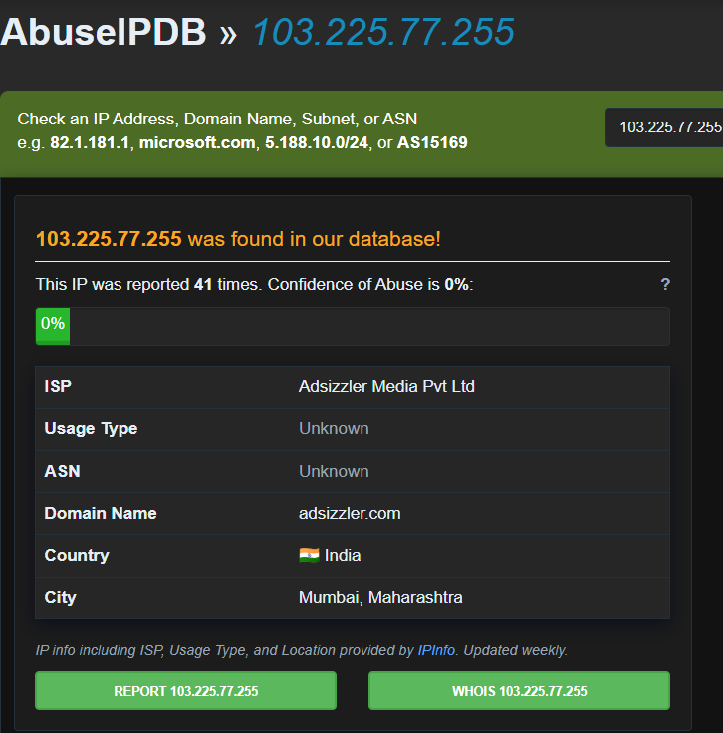Figure 2.1 : image showing status of IP address 103.225.77.255
The IP was ran through AbuseIPDB and the result shown that IP was report 41 times. Even though the email claimed that the IP originated from Russia, AbuseIPDB confirmed that IP was from India
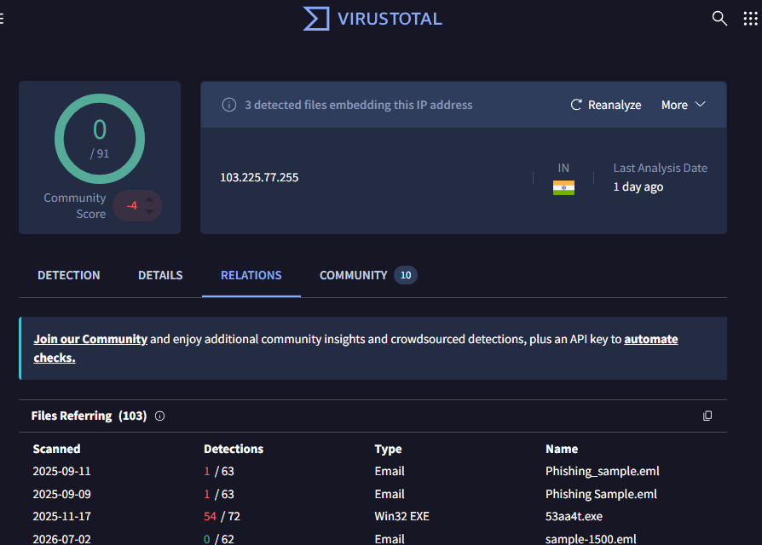
Figure 2.2: image showing status of IP 103.225.77.255 shown in the mail.

The output from VirusTotal shows that there are 3 embedding files in this IP address, this is very critical as these files could be unloaded into the organisations system if link is visited

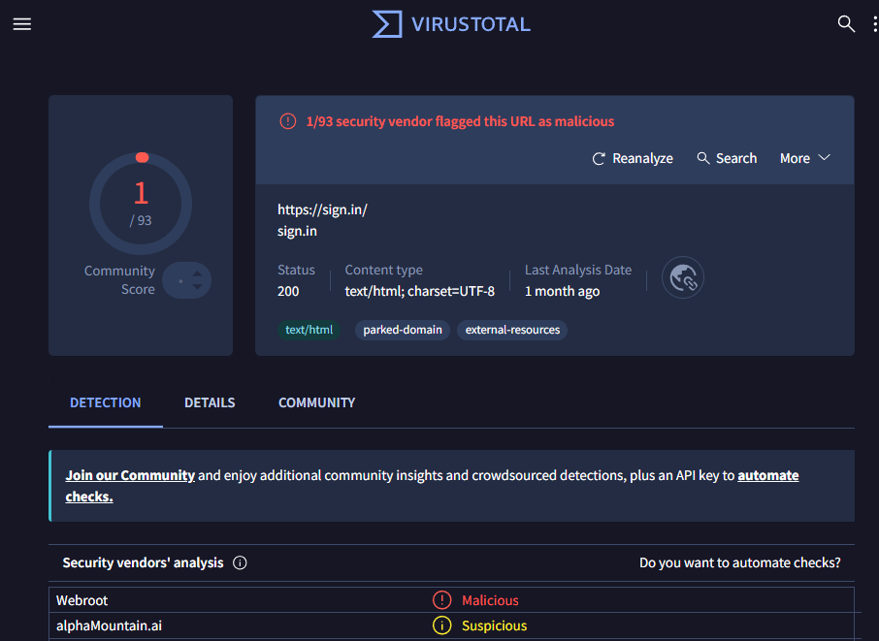Figure2.3 : images showing phishing link embedded in mail and result of phishing link analysis.
When i hovered the mouse on the link “secure your account” it redirects to https://sign.in/.
As shown in figure5.3, this link had once been reported at VirusTotal:as malicious.

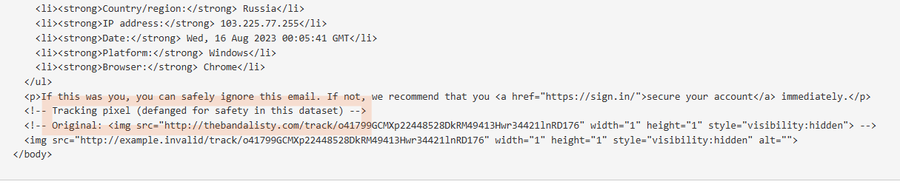
Ffigure3.0 : MXToolbox showing tracking pixel source to be thebandalisty.com
/sign.in/
./sign.in/
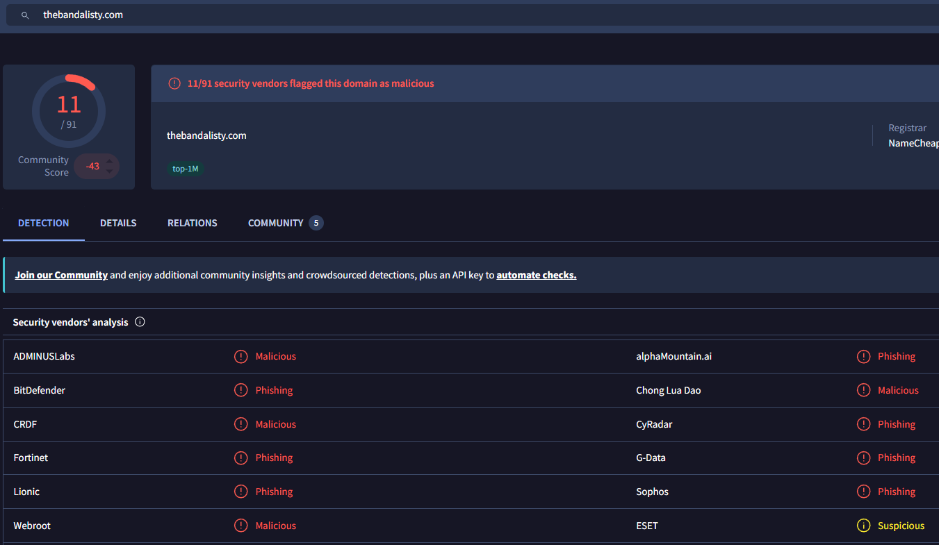Figure3.1: image of VirusTotal flagging the pixel source( thebandalisty.com) as malicious
VirusTotal reported that 11 vendors has flagged this domain as either phishing or malicious. This is a major cause for concern and more reason to treat this threat as critical.

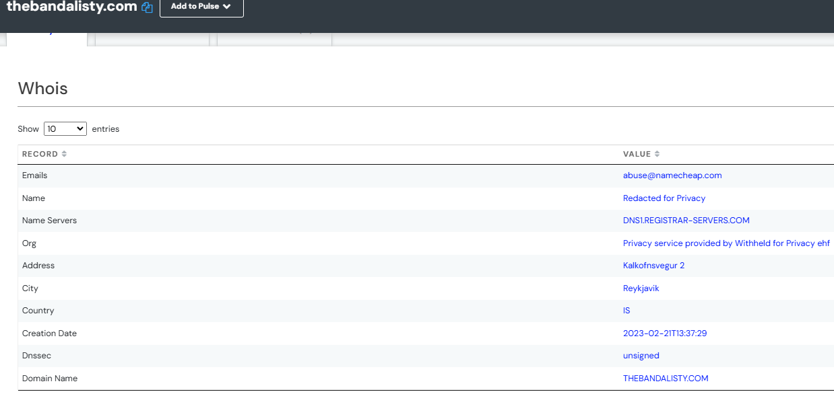Figure3.2 : image from AlienVault showing details about the domain thebandalisty.com
AlienVault reported that the domain resides in the Capital City of Iceland (Reykjavik), it also showed that Dnssec is unsigned. It’s shown that 31 passive DNS and 41 URLs are related to this domain.

